**DAILY ONLINE ACTIVITIES SUMMARY**

|  |  |  |  |  |  |  |  |  |
| --- | --- | --- | --- | --- | --- | --- | --- | --- |
| **Date:** | **06/06/2020** | | | | | **Name:** | **NIKHIL KUMAR** | |
| **Sem & Sec** | **4thSEM. & ‘B’ SEC.** | | | | | **USN:** | **4AL19CS400** | |
| **Online Test Summary** | | | | | | | | |
| **Subject 1** | | **DATA COMMUNICTION** | | | | | | |
| **Max. Marks(DC)** | | **30** | | **Score** | | | **28** | |
| **Certification Course Summary** | | | | | | | | |
| **Course** | **Java programing** | | | | | | | |
| **Certificate Provider** | | | **Greatlearning**  **Academy** | | **Duration** | | | **3.5 Hrs.** |
| **Coding Challenges** | | | | | | | | |
| **Problem Statement : Write a c program to rotate an array by N position.**  **Problem Statement : Write a java program. Given an array A of size N containing 0s, 1s, and 2s; you need to sort the array in ascending order.**  **Problem Statement : write a java program to find the second-highest number in an array** | | | | | | | | |
| **Status:executed** | | | | | | | | |
| **Uploaded the report in Github** | | | | | **Yes** | | | |
| **If yes Repository name** | | | | | **1 .** <https://github.com/Nikhil401/C-Coding/blob/master/rotate_array.c>  2. <https://github.com/Nikhil401/java-coding/blob/master/countzot.java>  3. <https://github.com/Nikhil401/java-coding/blob/master/SecondLargestInArrayExample.java> | | | |
| **Uploaded the report in slack** | | | | | **Yes** | | | |

**Online Test Summery : Subject Data Communication Test scheduled from 09:30 to 10:15 pm. The portion for the 3rd IA was 5th module and time assigned was 45 minutes and the number of questions were 30 and each contains 1 mark.**

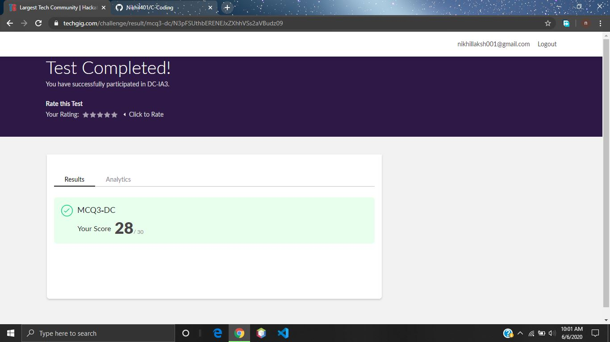

**Certification Course Summary: Today I have went through the all types of inheritance and abstract method in java programing and executed some programs….**

**Snapshot is given below…**

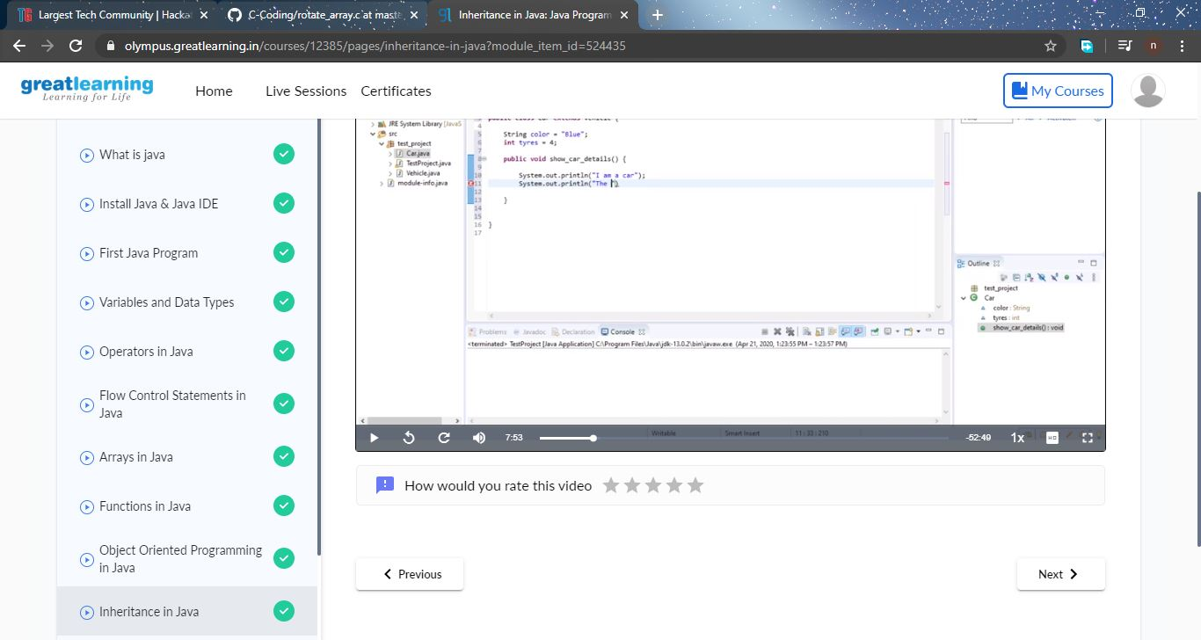

**Online Coding Summary: Today I received three programs from prof. venkatesh, prof . Shilpahassan and reenalobo CSE Dept. The program is mentioned above(pg.01). to my GitHub repository and I’ve shared the snapshot below.**

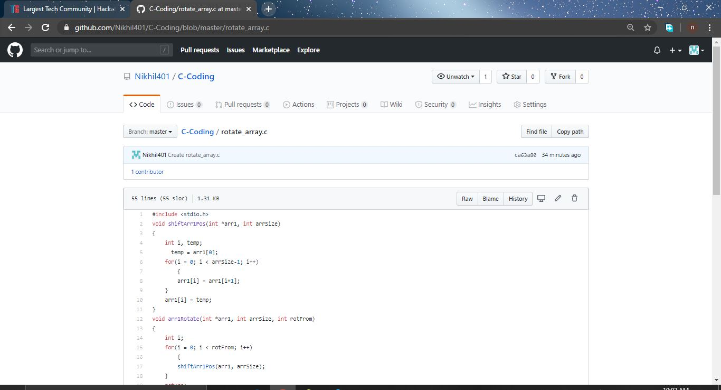

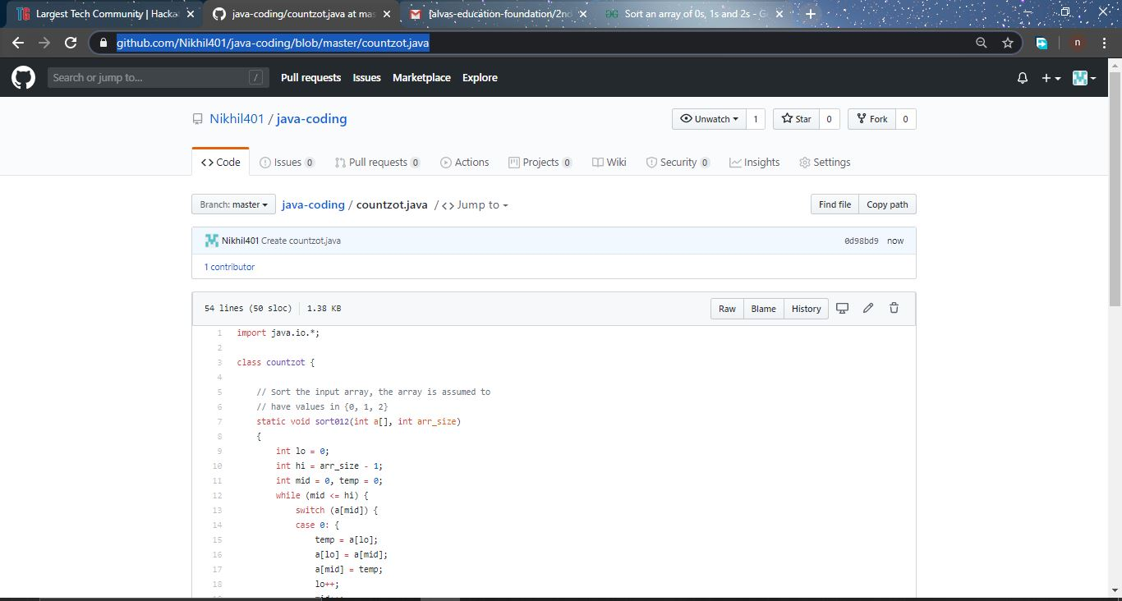

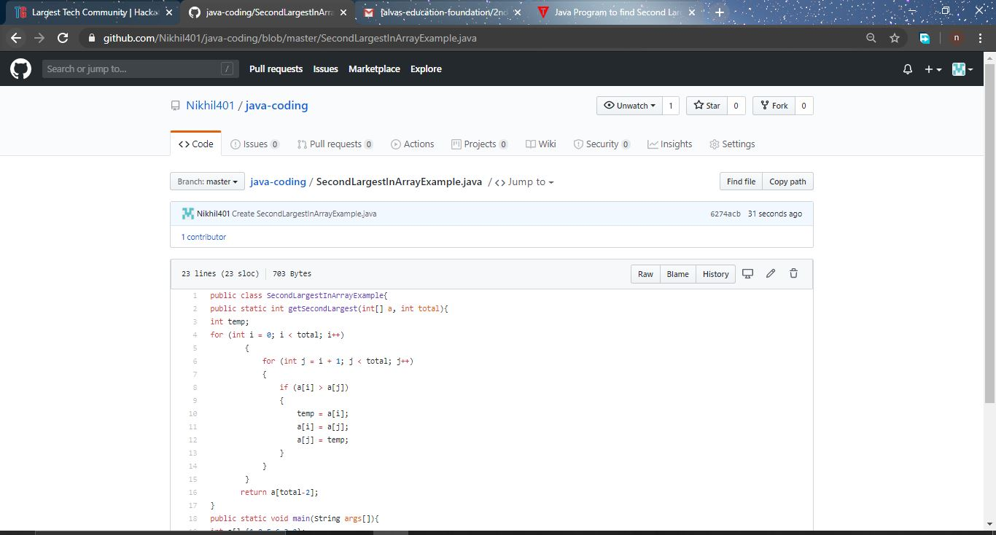**Thank you.**